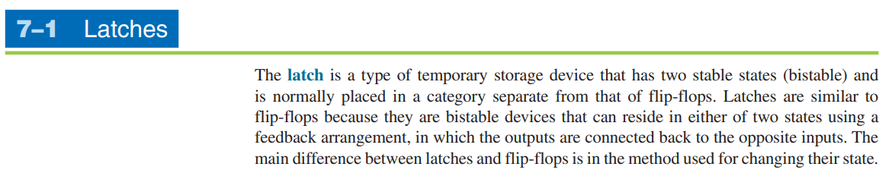

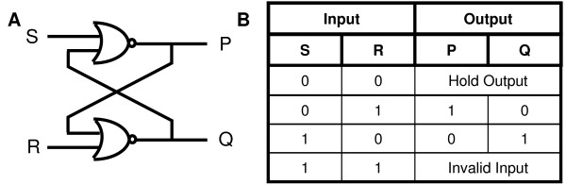

**The combinational circuit is time-independent. The output it generates does not depend on any of its previous inputs. On the other hand, sequential circuits are the ones that depend on clock cycles. They depend entirely on the past as well as the present inputs for generating output.**

